WASH Sector Tubewell Coding
Standard Operating Procedures: Updating the database
Between April and July 2019, the Cox’s Bazar WASH Sector and REACH are implementing a WASH infrastructure coding system, involving the coding of all tubewells. Each facility is tagged with a unique identifier ‘code’, with information for each facility (type, materials used, and location), which will be stored in a database and managed by the WASH Sector. The databases will be available to all partners from the WASH Sector as well as the Inter-Sector Coordination Group.
To ensure the database stays up-to-date and hence usable for operational and strategic purposes, the database requires regular updating when tubewells are decommissioned. For this scenario, a SOP for updating the database has been developed with the Water Technical Working Group (TWiG) within the WASH Sector, outlined below.
This SOP is relevant for the following WASH Sector partners, whose responsibilities in the response are as follows:
- Implementing partner (IP): responsible for implementation of WASH activities in the camps
- WASH Sector Information Management Unit: the Information Management Officers within the WASH Sector coordination team are responsible for updating the database, and managing the inventory of labels
SOP 1: Updating the database when facilities are decommissioned
When any type of facility is decommissioned, the database needs to updated with this information. The following SOP should be followed in this scenario:
- When a facility is being decommissioned, the IP records the facility type and unique identifier code (UID) of each decommissioned facility.
- The IP fills in this form. Instructions for filling in the form:
  - All fields marked with an asterisk (*) are required fields. These pieces of information are necessary for accurate follow up.
  - For type of infrastructure, select Tubewell(s) in case of tubewell decommissioning. The options Latrine(s) and Bathing cubicle(s) will not be relevant until the Sanitation Coding project is finalized (database expected to be released in November 2019).
  - For location, select the correct camp where the decommissioned tubewells are located.
  - For ‘Number of decommissioned infrastructures’, specify the number of decommissioned tubewells
  - For ‘Unique facility codes of decommissioned facilities’, specify the barcodes of the tubewells that are decommissioned. The number of barcodes should match the number of decommissioned facilities. In case there are two codes on the label, use the upper and smaller code that starts with 0 (see image 1).
  - If there are any other issues, or comments, you can make these in the comment section of the form.
  - Submit the form.
- The WASH Sector will receive the submitted form. On a monthly basis, the WASH Sector will update the database and change the status of these facilities from ‘functional’ or ‘non-functional’ to ‘decommissioned’.
Image 1: Specification which code to use
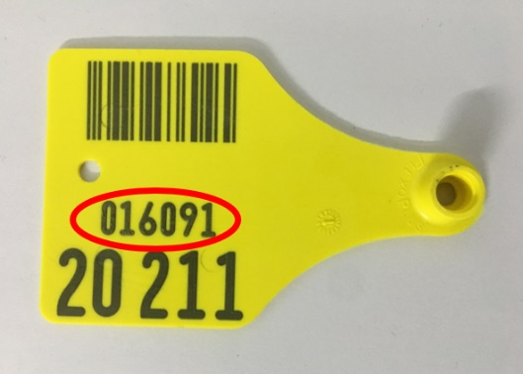
- The updated version of the database will be published on the WASH Sector’s webpage on HumanitarianResponse on a monthly basis and shared with partners on the WASH Sector’s email list.

