How to Extract COD Zip File to your Documents folder

- Double click the COD zip file (in this example, “COD-MLI.zip”)
- From File Explorer navigation ribbon, click “Extract all”
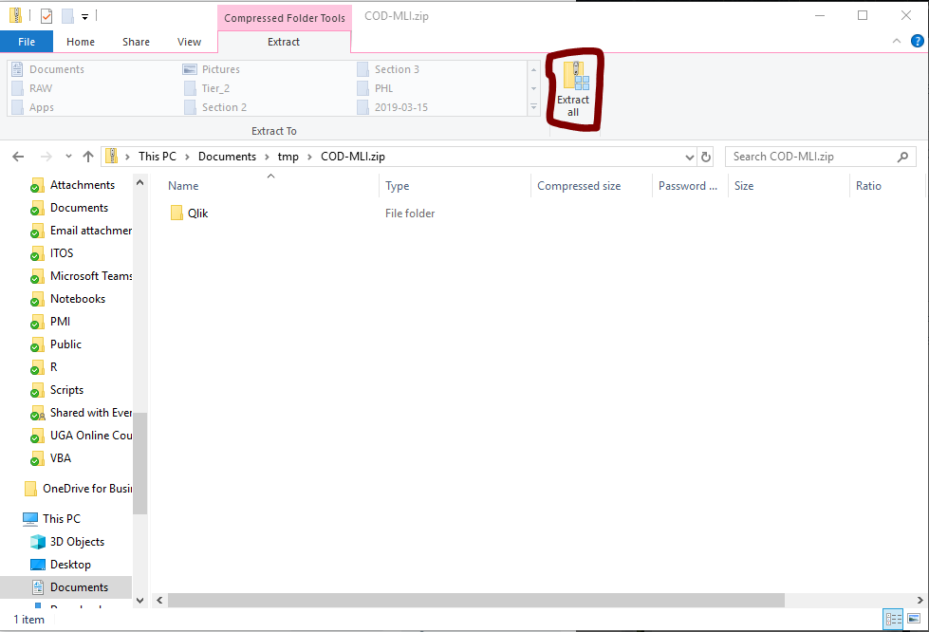
- “Extract Compressed (Zipped) Folders” window pop ups. Click “Browse…” button
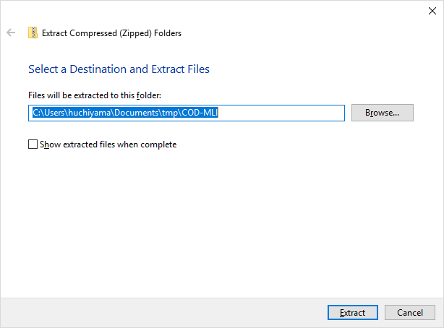
- Select “Documents” folder as the destination. You need to first select “This PC” and then select “Documents” as destination.
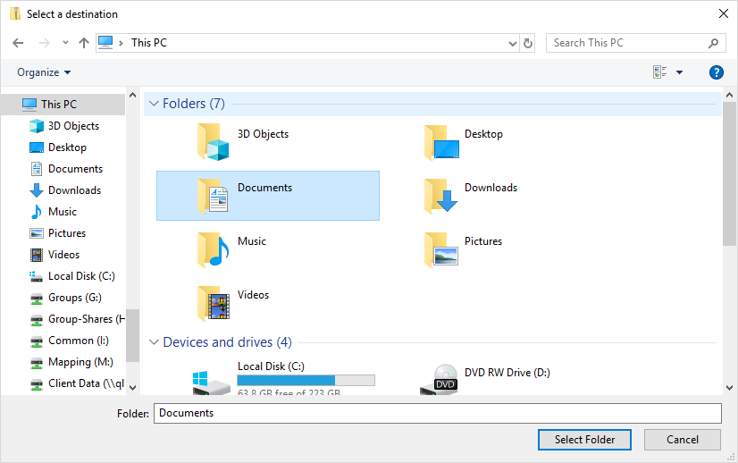
- Click “Select Folder” button. You should see the below screen now.
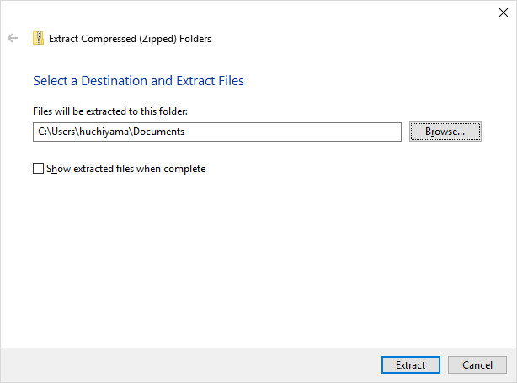
- Click “Extract” button

